**Name** – Norwich Testing Initiative

**Version** – 1.0

**Goal** – To sign up for two COVID tests

**Summary** – User uses site to book their COVID tests, seller receives shipping information and payment, user receives sellers good soon after

**Actors** – Applicant (Primary Actor), Norwich Testing Initiative (NTI) (Secondary Actor)

**Stakeholders** – UK Government, NHS, Members of the public

**Preconditions** – The applicant doesn’t already have COVID tests booked

**Triggers** – The applicant opens the webpage

**Happy/Success Path** –

1. Applicant opens the webpage through a web browser
2. Applicant clicks on the appropriate hyperlink
3. Applicant enters valid data into each respective textbox
4. Applicant selects first test date
5. Webpage allows it so the applicant can only pick another test from the following week onwards
6. Applicant selects second test date
7. Webpage verifies that all the correct data was submitted
8. Webpage stores the user’s information for external handling from the NTI
9. Applicant receives a message verifying that all the appropriate information was given
10. Applicant receives an email to their email they provided, confirming dates and times
11. Applicant leaves webpage

**Unhappy/Failure Path(s)** –

1.a) Applicant opens the wrong webpage

2.a) Applicant selects the wrong hyperlink

3.a) Webpage doesn’t load the textboxes

3.b) Applicant doesn’t provide valid data

4.a) Applicant selects a date which is unavailable. *Either through being booked out or before the current date*

5.a) Webpage doesn’t calculate the date correctly

6.a) Applicant selects a date which is unavailable. *Either through being booked out or before the current date*

7.a) No verification is provided

7.b) Verification is wrongfully provided as applicant has provided the incorrect data

8.a) Webpage doesn’t store information in the correct form

8.b) Webpage assigns data to the wrong file/file location

8.c) Webpage fails to store data completely

8.d) Webpage doesn’t send to the NTI

9.a) Webpage provides verification regardless of data

9.b) Webpage fails to provide verification even if provided data is correct

10.a) Applicant has provided incorrect email

10.b) Email fails to send

10.c) Email provides incorrect information

**Post conditions** – Norwich Testing Initiative receives the information provided by the applicant

**Notes** – May need to communicate with Norwich Testing Initiative in order to provide dates which are available

**Author and date** – Benji, Jon, James, Cam

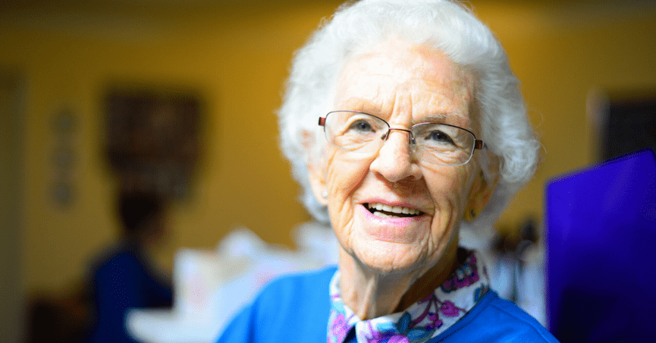

**Name**:

Andrea Smith

**Personal Background:**

71-year-old Caucasian woman who has a degree in Medicine (2:1) at London School of Economics. Widow.

**Professional Background:**

Andrea is a retired nurse of 40 years. She is now living off her pension in a cottage in Norwich.

**User Environment:**

Andrea spends most of her time at home on her sofa, occasionally going out to buy essentials and arts fairs.

**Psychographics:**

Andrea spends her free time producing bracelets and other garments for her local crafts fair in which she sells her handmade goods. She enjoys using her free time productively and making goods. A recent even has occurred at one of these fairs and now she wishes to apply for a COVID test.

**End Goals:**

Apply for a COVID test so she can return to her usual routine.

**Scenario:**

“I still wish to see my family throughout these times and receiving a COVID test will allow me peace of mind knowing I am less likely to pass this infection onto them. The fair is also making it a requirement that all vendors must pass a COVID test, as to prevent spreading through infected goods”.

**Name**:

Ashley Copper-Bottom

**Personal Background:**

19-year-old Caucasian woman who is currently studying for a Masters in Chemical Engineering at the University of East Anglea.

**Professional Background:**

Ashley is an ongoing student. She is now living in student housing with 4 others.

**User Environment:**

Ashley spends most of her time in the university’s library, studying for her course. She also goes to the campus’ bar on occasion to socialize.

**Psychographics:**

Ashley spends her free time browsing her social media accounts. Announcement about the plan to get students home for Christmas, she wishes to get tested as soon as possible.

**End Goals:**

Apply for a COVID test so she can return home for the holidays.

**Scenario:**

“I want to visit my family for the holidays as I’ve never spent a Christmas away from them and do not wish to pass this infection to my family or anyone who visits my accommodation”.